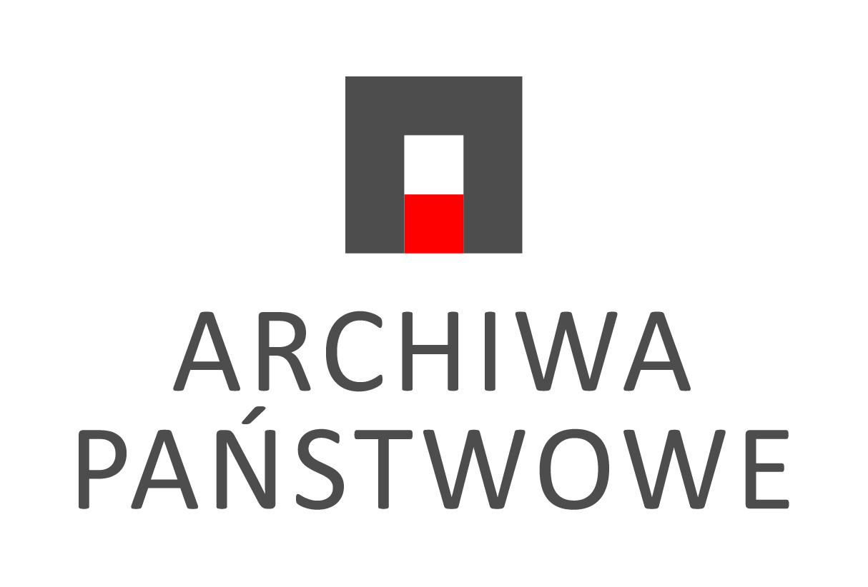

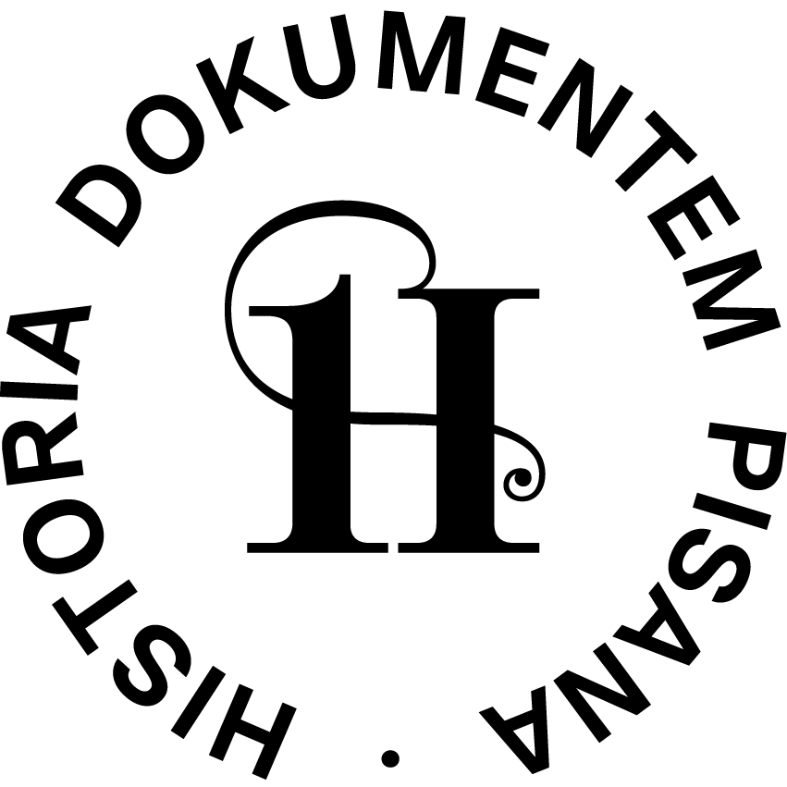

- Exhibition: History in Document
[presentation of the state archives network]
Organiser: State Archives in Poznań
Open-air exhibition: Plac Mickiewicza in Poznań;
- exhibition launch: 21 August 2022, 2:00 p.m.
- exhibition duration: from 21 to 28 August 2022

Indoor exhibition: building of the State Archives in Poznań, ground floor;
- exhibition duration: from 19 August to 30 September 2022
“A nation that disrespects its past does not deserve the respect of the present and has no right to a future” (Józef Piłsudski)
The State Archives in Poznań, to honour the events accompanying the 23rd International Congress of Historical Sciences, has prepared an exhibition “History in Document”, aimed at reminding international scholars of the diversity of Polish history, as well as drawing attention to the Archives, highlighting the content and value of the resources held there.
The presentation is based on two basic elements. The first part of the exhibition, “History in Document”, is an open-air display staged in the city centre during the Congress. It is the fruit of cooperation between all 33 State Archives that constitute the Polish archives network.
The word “document” in the title, according to the concept of the originators of the exhibition, was to be the oldest item stored in a particular archives. The request to prepare the oldest document was dictated by the particular interest of the State Archives in Poznań, since it is in our collection that the oldest surviving document, issued in the Polish lands, has been preserved i.e., the foundation act of the Cistercian monastery by Zbylut, a Polish citizen, in Łękno near Wągrowiec in 1153, which in 2016 was included in the Polish National Register of the UNESCO “Memory of the World” Programme.
The selected exhibits, dating from the 12th to the 20th centuries, show a range of diverse themes. For the most part, they are medieval papal, royal, monastic, municipal and guild documents. To name just a few figures: Hadrian IV, Celestine III, Gregory IX, John XXII, Bolesław I the Tall, Bolesław the Chaste, Władysław Łokietek, Casimir the Great, Sigismund Augustus. In addition to these, there are also court, mortgage and family records. The most recent are from the 19th and 20th centuries, i.e. the only photograph in the exhibition, a portrait of the Polish painter and pianist, Maria Wodzińska, and a document from 1918 granting power to Józef Piłsudski after Poland regained its independence.
An addition enriching the open-air exhibition is the display prepared at the headquarters of the State Archives in Poznań. The International Congress of Historical Sciences is an excellent opportunity to allow those who are interested to get familiar with original documents in addition to the copies presented at the open-air exhibition. For the duration of the Congress, the second display of “History in Document” exhibition was prepared in the lobby of the State Archives in Poznań, which is a unique event; for rarely can the originals, the storage of which is subject to special procedures, be admired directly by general public.
Its first part features the items inscribed on the World and Polish National Register of the UNESCO “Memory of the World” Programme: Zbylut’s foundation act of Łękno Monastery from 1153 (inscribed in 2016); the foundation of Trzebnica Hospital for the poor by Elżbieta Bitowska from 1565 (the entire set of Czech Brethren Acts entered in 2015); and the daily orders of the General Command of the Polish Armed Forces, signed by Major Stanisław Taczak, the first commander and commander-in-chief of the Wielkopolska Uprising, and his successor General Józef Dowbor-Muśnicki, dated 1919 (entry in 2018).
The second part of the exhibition features documents signed by Polish princes and kings: Boleslaw the Pious, Casimir Jagiellon, Alexander Jagiellon, Sigismund the Old, Jan III Sobieski, Stanisław Leszczyński, Augustus II the Strong, Augustus III of the Wettin Family, Stanisław August Poniatowski. Poznań archives contain an abundance of artefacts produced by papal chancelleries, including those with the signatures of Pope Gregory IX in 1294 and Pope Innocent X from 1652.
The presentation of parchment and paper documents is complemented by 45 seal dies selected from the collection of Seal Dies of Various Offices and Institutions held in Poznań archives. The main highlight, i.e. the “senior” of the exhibition, is undeniably the seal die of the city of Poznań from the first half of the 14th century, made of brass and gold.
Both presentations are intended, in addition to honouring the spectacular event of the International Congress of Historical Sciences held in Poland for the second time, above all to encourage Poles to get acquainted with the testimonies of their rich history, hidden in the archives which are the treasuries of the past.

